Programming 6212 POE Web Application

2016

Adrian Beukes 15002426

**Content**

Specifications ………………………………………………………………………..2 Purpose Functional Requirements

Test Data ………………………………………………………………………..3

Flow Diagram ………………………………………………………………………..7

Class Diagram ………………………………………………………………………..8

Error Handling …………………………………………………………………….....9

Help ………………………………………………………………………..9

**Specifications:**

Purpose:

The Purpose of this web application is to create a web service, which would allow for patient to create their own appointments through the use of the website. The site must be usable and update the database information, linking to the windows form and mobile app through the database so all information will be up to date at all times.

My program works on a windows web application, with the integration of the databases and use that input to give the wanted outcome/reports, in this case, making a booking to see the physician.

Functional Requirements:

In my web application you can do the following:

* Find information about Durban First Health
* Find contact details about Durban First Health
* Allow users to create a booking, with date and time in order to see physician.

All of the above was met, with great design and ease of use.

**Test Data**

A few screenshots of my program will follow, with explanation of what’s happening at each stage, as I progress in order to test it:

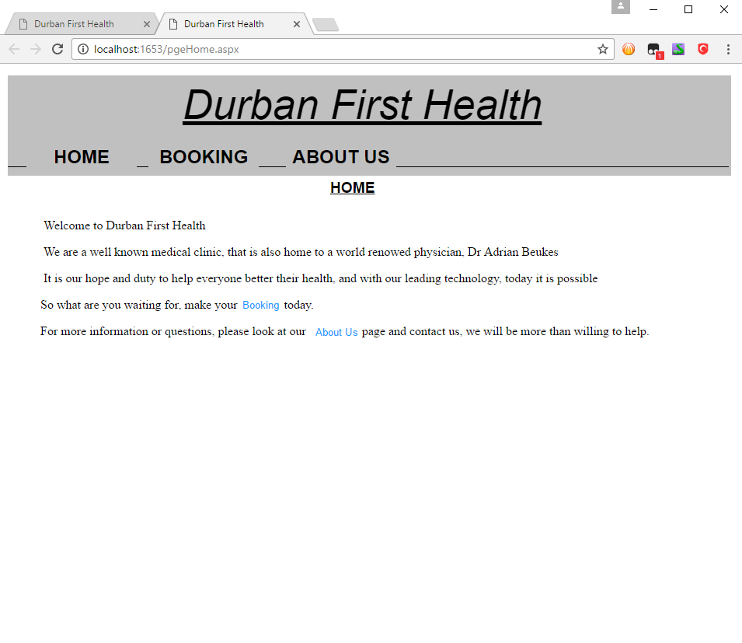

This is the home page for the web application, where you can find all information related to Durban First Health, as well as browsing options and hyperlinks to go to the booking and about us part of the web application.

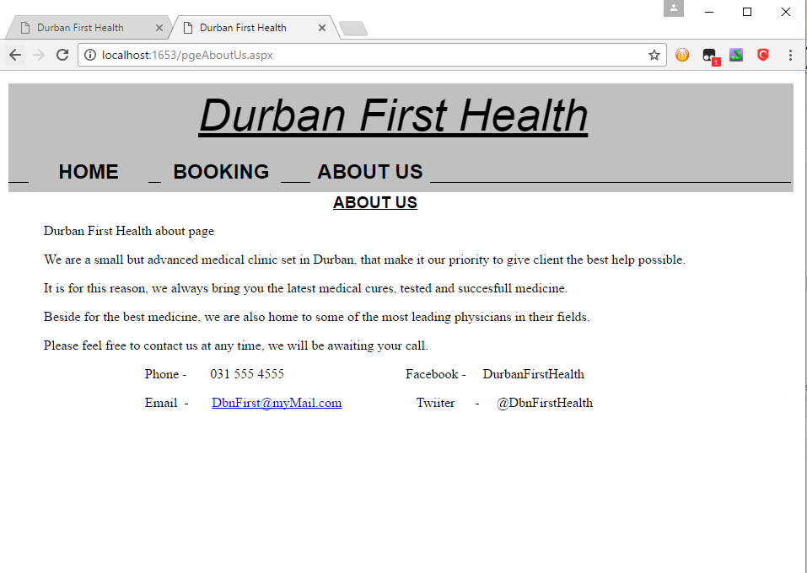

Here you can see the about us, giving a bit more information than the home page on Durban First Health, like where it is established, what makes it the first choice, as well as contact details, which you can follow to get more information or ask specific questions to us directly.

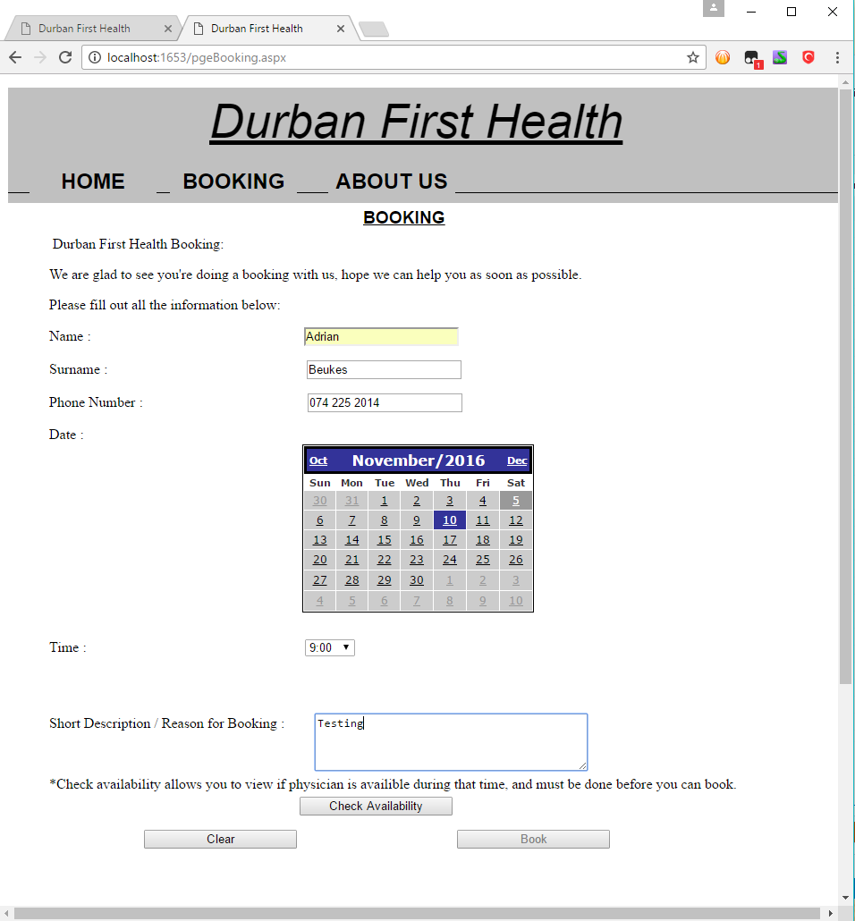

This is the booking page, where any patient can go ahead and fill in their booking information, please note that you do need to fill in all the information before you can place a booking, and need to do a check availability for the physician, to see if he is free, or busy at that current time, before you can press the booking butt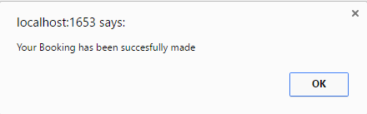

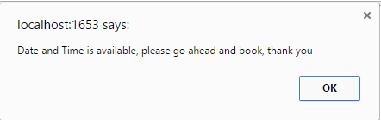

These are just some of the confirmation we show in order to validate before a booking can be made.

**Flow Diagram:**

Home

Booking

About Us

**Class Diagram:**

**Durban First Health (web)**

Users (Perma)

Users (Active)

Admin

Patient

Database

**Error Handling:**

For my error handling I added validation to make sure the user enters all needed information.

There’s also a check availability button in the booking page to make sure the date and time is available. This button also allows for the booking button to be enabled after checking if you can book at the specific time.

**Help:**

This is a guide that would take you step for step through the application.

On opening the web application, you will be in the home page, there you can find information on Durban First Health and at the top, and you will find Heading names, which can be used to browse to the other pages, Booking and About Us. There is also a couple of hyperlinks in a different colour, blue, to distinguish itself, and can also be used as an alternative for browsing to the other pages.

In the about us page, you can find even further information, and it tells you a bit more about Durban First Health, as well as give information for contacting us, in order to ask further questions or just to follow us for staying up to date on latest news.

In the booking page, you can fill out your information in order to do a successful booking, please note that all information must be completed, and it will be validated that everything is entered, or tell you exactly, what you still need to enter. Before you can press the booking button, you need to press the check availability button, in order to see if the requested date and time is available for the physician, if it is available, the booking button will be enabled, and you will receive the notification that booking may now be done. Upon successful booking, you will receive another notification to let you know it was a success.